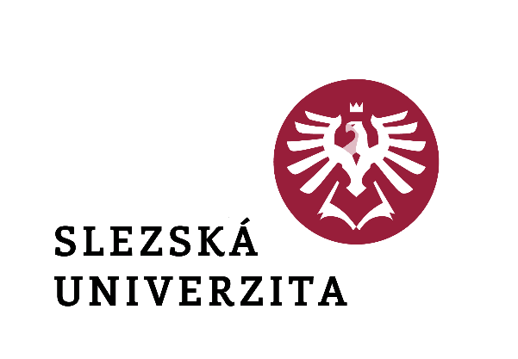

Rector's Decision No. 9/2024

**Announcement of the Rector's Scholarship Programme**

**for the academic year 2024/2025**

**to support talented students**

**at the Silesian University in Opava**

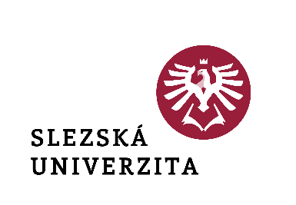

Rector's Decision No. 9/2024

**Announcement of the Rector's Scholarship Programme  
for the academic year 2024/2025**

**to support talented students**

**at the Silesian University in Opava**

**Article 1**

**Introductory provisions**

1. This Decision announces the Rector's Scholarship Programme for the academic year 2024/2025 to support talented students at the Silesian University in Opava (hereinafter referred to as the "Rector's Programme") and sets out the conditions for awarding an extraordinary scholarship pursuant to Article 7(1)(c) of the Scholarship Regulations of the Silesian University in Opava (hereinafter referred to as the "Scholarship Regulations" or "University"), as amended.
2. This Rector's Programme does not apply to students with exceptional sporting performance who are supported by the Rector's Scholarship Programme to support the study of students with exceptional sporting performance at the Silesian University in Opava in the relevant academic year, as amended.

**Article 2**

**Definition of the range of students and conditions for awarding the scholarship**

1. The one-time exceptional scholarship for talented students will be awarded to full-time and combined students who are students in an accredited study programme in the academic year 2024/2025 and who meet one of the following conditions:
   1. achieved success in competitions and Olympiads at national and international level in the calendar year 2024;
   2. have achieved exceptional results in the field of creative and artistic activity;
   3. Demonstrably and actively engaged in university-wide activities.
2. The students concerned must not be proven to have failed to fulfil their obligations under Section 63 of Act No.111/1998 Coll., on Higher Education Institutions and on Amendments and Additions to Other Acts, as amended (the Higher Education Act).
3. The one-off scholarship referred to in paragraph 1(a) is awarded to students who deliver documents proving their eligibility for the scholarship by the deadline electronically via the "Office" application in the information system of the Silesian University in Opava (hereinafter referred to as "SU IS"), Rector's Office > Department for Academic and Social Affairs > Application for Scholarship - Talent Scholarship, as follows
   1. in the period from 1 to 31 January 2025, unless they are art study programmes and the condition is fulfilled that their minimum gain of 15 credits for completing the enrolled study obligations is registered in the IS SU as of 31 January 2025;
   2. in the period from 1 to 30 June 2025, if they are artistic study programmes and the condition is fulfilled that their minimum gain of 30 credits for completing the enrolled study obligations is registered in the IS SU as of 30 June 2025.
4. The one-off scholarship under subsection 1(b) and (c) is awarded on the basis of a proposal submitted on behalf of the relevant unit of the university by its head (dean, director), electronically on the prescribed form via the IS SU by the deadline:
5. Until 31 March 2025 for student achievement awards for the period 1 September 2024 to 28 February 2025;
6. Until 31 August 2025 for student achievement awards for the period 1 March 2025 to 31 August 2025.

Proposals for scholarships are submitted by the Vice-Rector for Student and Social Affairs for consideration by the University management at the next management meeting or electronically with regard to the related administration of scholarships by the responsible employee of the Department for Student and Social Affairs of the Rector's Office.

**Article 3**

**Amount of scholarship**

1. The amount of the scholarship for students who have completed their studies at secondary school in the school year 2023/2024 and are enrolled for the first time at the University of Silesia and who also meet the condition under Article 2(1)(a) is set as follows:
2. CZK 10,000.- for students who have been successful solvers of the regional round of one of the subject competitions announced pursuant to Section 3 (1) of Decree No. 55/2005 Coll., by the Ministry of Education, Youth and Sports of the Czech Republic (hereinafter referred to as the competition "MŠMT ČR");
3. 12.000,- CZK for students who were successful solvers in the central round of the competition of the Ministry of Education of the Czech Republic during their studies at secondary school;
4. CZK 15,000.- for students who placed 1st - 3rd in the central round of the competition of the Ministry of Education of the Czech Republic during their studies at secondary school.
5. The amount of the scholarship for students who have participated in a competition for students of colleges and universities announced by the Ministry of Education and Science or other public institutions and thus meet the condition under Article 2(1)(a) is set as follows:
6. 10.000,- CZK for students who ranked 7th to 10th during their studies at the university;
7. 15.000,- CZK for students who ranked 4th to 6th during their studies at the university;
8. 20.000,- CZK for students who ranked 1st to 3rd during their studies at the university.
9. The amount of the scholarship for students who have achieved extraordinary results in the field of creative and artistic activities or who have demonstrably and actively participated in university-wide activities is proposed to the Rector by the Vice-Rector for Academic and Social Affairs, taking into account the outcome of the discussion at the management meeting pursuant to Article 2(4) of the Rector's Programme, based on an assessment of the documents submitted. For each period (September 2024 to February 2025, March 2025 to August 2025) a maximum amount of CZK 100,000 is allocated from the University Scholarship Fund.
10. If a student fulfils the conditions for awarding a scholarship in more than one of the categories listed in paragraphs 1 and 2, the highest possible amount is awarded; the scholarships in each category are not cumulative. In cases worthy of special consideration, the Rector may award a scholarship in an amount corresponding to the conditions of the competition of the higher category if comparable results are otherwise documented.

**Article 4**

**Payment of the scholarship**

The scholarship is paid in accordance with the Scholarship Regulations after the legal validity of the decision on its award, in cashless form to the student's bank account listed in the IS SU. If the student does not have valid bank account details filled in in the IS SU, the scholarship will not be paid.

**Article 5**

**Common provisions**

1. Changes in the amount and withdrawal of scholarships are regulated in Article 18 of the Scholarship Regulations.
2. Article 25 of the University Statutes, as amended, applies to the delivery of decisions on the awarding of scholarships - decisions are delivered via the IS SU.
3. Administrative activities related to the registration of applications for support and the awarding of scholarships, including their payment in the IS SU are provided by the responsible employee of the Department for Student and Social Affairs of the Rector's Office.
4. If there is any doubt about the authenticity of a plain copy of the documents proving eligibility for the scholarship, the responsible officer of the Rector's Office for Student and Social Applications may require the submission of original documents.

**Article 6**

**Final provisions**

This Decision shall enter into force and effect on the date of its publication.

In Opava on 29 May 2024

|  |  |
| --- | --- |
|  | doc. Mgr. Tomáš Gongol, Ph.D. |
|  | Rector |

|  |  |
| --- | --- |
| Part of the university: | Rector's Office |
| Designation: | **Rector's decision** |
| Number: | **9 /2024** |
| Name of the standard: | **Announcement of the Rector's Scholarship Programme for the academic year 2024/2025 to support talented students at the Silesian University in Opava** |
| Approves: | doc. Mgr. Tomáš Gongol, Ph.D. |
| Derogation: |  |
| Validity from: | on the date of announcement (publication) |
| Effectiveness from: | on the date of announcement (publication) |
| Release Date: | 29.05.2024 |
| Published by: | Rector |
| Elaborated by: | Ing. Hana Šimečková |
| He collaborated: | doc. PhDr. Michaela Weiss, Ph.D. |
| Number of pages: | 6 |
| Number of attachments: | - |
| Method of publication | public (web) |
| Translation into AJ | YES |
| Area of adjustment | Study |
| Adaptation minimum |  |