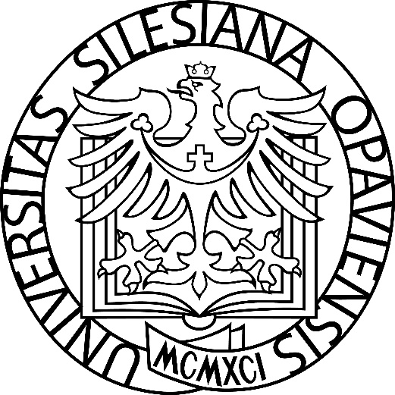

I. Change
Disciplinary Regulations for Students of the Silesian University in Opava
dated ..... 2025

I. Amendment
Disciplinary Regulations for Students of the Silesian University in Opava
dated ..... 2025

Article 1
The Disciplinary Regulations for Students of the Silesian University in Opava of 25 August 2025 are amended as follows:

- A new paragraph 7) is added to Article 2, which reads as follows:
"7) In accordance with Section 66 of the Act, a disciplinary offence cannot be heard if a period of one year has elapsed since the offence was committed or since the final conviction in a criminal case. The period of one year shall be interrupted by the notification of the initiation of disciplinary proceedings; the interruption of the period shall start a new period of one year. The period of time during which the individual is not a student and the period during which the matter has been the subject of administrative proceedings shall not be included in the time limits."

- In Article 3, paragraphs 1), 2) and 6) are deleted and replaced by new paragraphs 1), 2) and 6), which read as follows:
"(1) The University Disciplinary Committee (hereinafter referred to as "the Committee") shall have four members, including a chairperson, two of whom shall be academic staff of the University and two of whom shall be students of the University.
2) The members of the Commission shall be appointed and dismissed by the Rector with the prior approval of the Academic Senate of the University. The members of the Commission shall elect a chairperson from among its members. The term of office of the members of the Commission shall be four years."
6) No member of the Board may take part in the deliberations of the Board whose impartiality may be doubted with regard to the matter under consideration or the person of the student suspected of having committed a disciplinary offence. Each member of the Board shall be required to give notice of his or her possible bias or the bias of another member of the Board. The decision to exclude a member of the Board for bias shall be taken by the Chairperson of the Board on the basis of the notification. The Rector shall decide on the expulsion of the chairman of the commission for bias and at the same time shall delegate the chairmanship of the case to another member of the commission."

- In Article 4, paragraph 4) is deleted and replaced by the following:
"(4) Disciplinary proceedings shall be initiated by the student's knowledge of the proposal."
- In Article 5, the word "reasonably" is deleted.
- In Article 7, paragraph (4) shall be deleted without replacement; the existing paragraphs (5) to (7) shall be renumbered as paragraphs (4) to (6).
- In Article 7, paragraph (3) is deleted and replaced by a new paragraph (3) which reads as follows:
"(3) If the Board decides on a proposal under Article 6(6)(a) or (b), or under Article 6(7)(a) or (b), the Rector may
- impose the sanction proposed by the Board, or
- impose a lesser sanction, or
- refrain from imposing a sanction if the hearing of the disciplinary offence itself will lead to a remedy.
- In Article 7(4), the word "that" shall be replaced by "whether".
- Article 8 is deleted and replaced by a new Article 8, which, including the heading, reads as follows:
'Article 8
Appeal procedure
- The appeal procedure shall be governed by Section 68 of the Act.
- The Rector shall decide on appeals against decisions.
- The lodging of an appeal shall always have suspensive effect."

Article 2
Transitional and final provisions
- The existing membership of the members of the Disciplinary Board shall cease on the entry into force of this amendment.
- These amendments to the Disciplinary Regulations for Students of the Silesian University in Opava were approved pursuant to Section 9(1)(b)(3) of the Act by the Academic Senate of the Silesian University in Opava on
6 May 2025.
- These amendments come into force pursuant to Section 36(4) of the Act on the date of registration by the Ministry of Education, Youth and Sports.
- These amendments shall come into force on 1 September 2025.

Ing. Lucie Kamrádová, Ph.D. | doc. Mgr. Tomáš Gongol, Ph.D.
Chair of the Academic Senate | Rector

