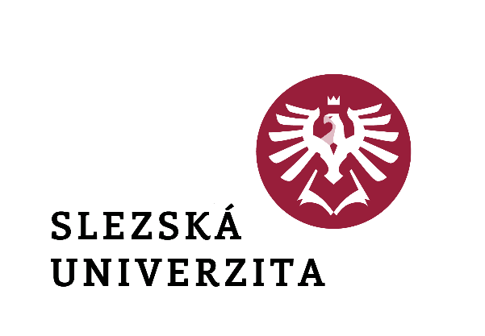

Rector's Decision No. 10/2024

**Announcement of the Rector's Scholarship Programme**

**to support the studies of students in the first year of bachelor's degree programmes enrolled for the first time at the Silesian University in Opava  
in the academic year 2024/2025**

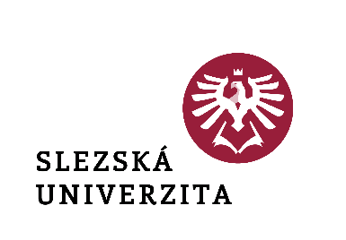

Rector's Decision No. 10/2024

**Announcement of the Rector's Scholarship Programme**

**to support the studies of students in the first year of bachelor's degree programmes enrolled for the first time at the Silesian University in Opava  
in the academic year 2024/2025**

**Article 1**

**Introductory provisions**

This Decision announces the Rector's Scholarship Programme to support the studies of first-year students of Bachelor's degree programmes enrolled for the first time at the Silesian University in Opava in the academic year 2024/2025 and sets out the conditions for the award of an extraordinary scholarship pursuant to Article 7(1)(c) of the Scholarship Regulations of the Silesian University in Opava (hereinafter referred to as the "Scholarship Regulations"), as amended.

**Article 2**

**Definition of the range of students and conditions for awarding the scholarship**

1. The exceptional scholarship will be awarded to full-time and combined students who have completed their studies in one of the following ways in the 2023/2024 academic year:
   1. have completed their secondary education;
   2. have completed higher vocational education in a conservatory by successfully completing a six- or eight-year education programme;
   3. they have obtained a foreign secondary education by completing their studies in a secondary education programme in a foreign secondary school, an international secondary school, a European school operating under the Convention relating to the Statute of the European Schools, or a school where the Ministry has authorised compulsory school attendance under the Education Act.
2. As a condition for the award of the exceptional scholarship, documents (simple copies will suffice) proving eligibility for the scholarship must be received by 31 October 2024 at the latest by one of the following methods:
   1. in person at the Department for Student and Social Affairs of the Rector's Office, at Olbrichova 625/25, Opava;
   2. in writing to the address of the Silesian University in Opava, Department for Academic and Social Affairs of the Rector's Office, Na Rybníčku 626/1, 746 01 Opava;
   3. electronically via the application "Office" in the information system of the Silesian University in Opava (hereinafter referred to as "IS SU"), agenda Rectorate > Department for Student and Social Affairs > Scholarship Application - Rector's Scholarship Programmes (talent, donation, sports...).

Documents delivered in person or in writing must be accompanied by information about the student's identification data (course, study programme, or specialisation). In addition to documents proving foreign secondary education, the student shall attach information on the foreign secondary education system, including a conversion table of grades if it does not match the Czech grading system (1-5).

1. In the academic year 2024/2025, the students concerned must have a minimum gain of 10 credits for completion of registered study obligations as of 20 January 2025 and a minimum gain of 30 credits for completion of registered study obligations as of 30 June 2025 recorded in the SU IS.
2. Paragraph 3 shall not apply to students on arts degree programmes and the achievement of a minimum of 30 credits for the completion of registered study requirements shall be assessed as at 30 June 2025.

**Article 3**

**Amount of scholarship**

1. The scholarship will be awarded in the amount corresponding to the maximum amount possible under the conditions set out in paragraph 2 - scholarships in individual categories are not cumulative.
2. The amount of the scholarship is set as follows:
3. CZK 2,000 per month for students whose overall arithmetic average of all grades listed on the conservatory graduation certificate or on the document proving completion of foreign secondary school studies reaches a maximum value of 1.25;
4. CZK 2,000 per month for students who have passed the matriculation examination in the common part of each subject with a pass mark and a pass percentage of 85% or more;
5. CZK 2,000 per month for students whose overall arithmetic average of all grades on the school leaving certificate in the profile part of the course reaches a maximum of 1.20;
6. CZK 2,000 per month for students who have won awards in competitions for secondary school students organised by the Silesian University in Opava or its components (competitions for the best professional essay, competitions and activities of student teams, etc.) in the school year 2023/2024;
7. CZK 3,000 per month for students who have passed the matriculation examination in individual subjects in the common part with a pass mark and a pass percentage of 85 % or more and whose overall arithmetic average of all grades listed on the matriculation certificate for the profile part subjects reaches a maximum value of 1.20;

**Article 4**

**Payment of the scholarship**

1. For each student who meets the conditions for the award of the scholarship, the exceptional scholarship will be paid in the maximum amount possible for a maximum of 10 months in an academic year (September 2024 to June 2025). The scholarship will be paid for the period September-December 2024 by the end of January 2025 and for the period January-June 2025 by the end of July 2025; for students in arts programmes in one instalment for the period September 2024 to June 2025 by the end of July 2025.
2. If the student graduates during the month, the entitlement to the scholarship will expire on the last day of the month preceding the graduation.
3. The scholarship is paid in accordance with the Scholarship Regulations after the legal validity of the decision to award the scholarship, in cashless form to the student's bank account listed in the IS - if the student does not have valid bank account details filled in the IS, the scholarship will not be paid.

**Article 5**

**Common provisions**

1. Reduction and withdrawal of the scholarship is regulated in Article 18 of the Scholarship Regulations.
2. Decisions are delivered via the IS SU.
3. If there is any doubt about the authenticity of a plain copy of the documents proving eligibility for the scholarship, the responsible officer of the Rector's Office for Student and Social Applications may require the submission of original documents.

**Article 6**

**Final provisions**

This Decision shall enter into force and effect on the date of its publication.

In Opava on 29 May 2024

|  |  |
| --- | --- |
|  | doc. Mgr. Tomáš Gongol, Ph.D. |
|  | Rector |

|  |  |
| --- | --- |
| Part of the university: | Rector's Office |
| Designation: | **Rector's decision** |
| Number: | **10/2024** |
| Name of the standard: | **Announcement of the Rector's Scholarship Programme**  **to support the study of first-year students of bachelor's degree programmes enrolled for the first time at the Silesian University in Opava in the academic year 2024/2025** |
| Approves: | doc. Mgr. Tomáš Gongol, Ph.D. |
| Derogation: | Rector's Decision No. 8/2022 |
| Validity from: | on the date of announcement (publication) |
| Effectiveness from: | on the date of announcement (publication) |
| Release Date: | 29.05.2024 |
| Published by: | Rector |
| Elaborated by: | Ing. Hana Šimečková |
| He collaborated: | doc. PhDr. Michaela Weiss, Ph.D. |
| Number of pages: | 5 |
| Number of attachments: | - |
| Method of disclosure: | intranet, publicly accessible |
| Translation into AJ | YES |
| Area of adjustment | Study |
| Adaptation minimum |  |