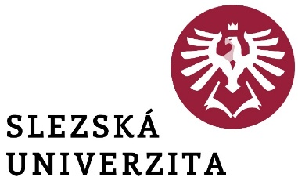

IV. Amendments

Rector's Directive No. 6/2021

**Rules for the creation of the Social Fund   
and the granting of contributions from the Social Fund**



IV. Amendments

Rector's Directive No. 6/2021

**Rules for the creation of the Social Fund   
and the granting of contributions from the Social Fund**

**Article 1**

1. The text of **Article 5 - Provision of the amount of the catering allowance from the Fund**, paragraph 2) is deleted and replaced by the following text:

2) The amount of the employer's contribution for meals from the Fund is CZK 5.50 for each meal voucher or main meal provided.

**Article 2  
Final provisions**

These amendments shall enter into force on the date of their publication on the intranet and shall take effect on 1 July 2025.

In Opava on

doc. Mgr. Tomáš Gongol, Ph.D.  
 Rector

|  |  |
| --- | --- |
| Part of the university: | Rector's Office |
| Designation: | **Rector's Directive** |
| Number: | **IV. Amendment to Rector's Directive No. 6/2021** |
| Name of the standard: | **Rules for the creation of the Social Fund  and the granting of contributions from the Social Fund** |
| Approves: | doc. Mgr. Tomáš Gongol, Ph.D. |
| Derogation: | --- |
| Validity from: | the date of publication on the intranet |
| Effectiveness from: | 1. 7. 2025 |
| Release Date: |  |
| Published by: | Rector |
| Elaborated by: | Ing. Ivana Růžičková, MPA |
| He collaborated: |  |
| Number of pages: | 1 |
| Number of attachments: | - |
| Method of publication | Intranet |
| Translation into AJ | YES |
| Area of adjustment | general (for all employees) |
|  | labour law agenda |
| Adaptation minimum | all employees |