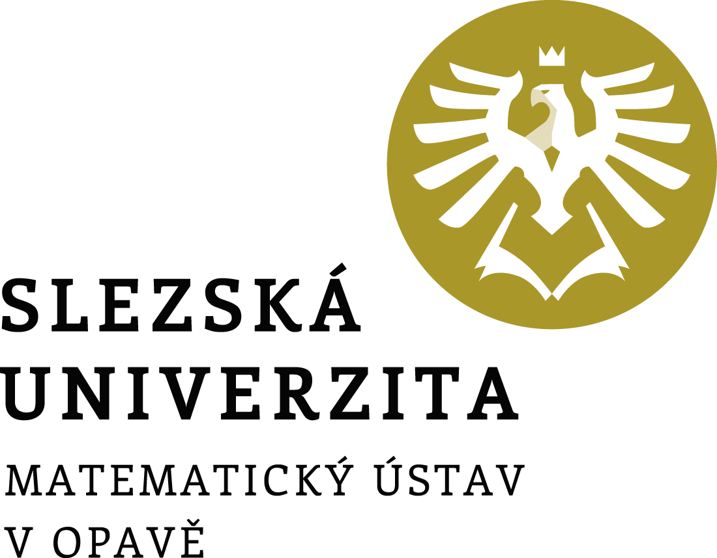

Director's Decision No. 3/2023

Academic Year Schedule

2023/2024

Director's Decision No. 3/2023

Academic Year Schedule 2023/2024

Article 1
Academic year schedule
In accordance with article 3, paragraph 6 of the Study and Examination Code for Students of Bachelor's and Master's Study Programmes of Silesian University in Opava, as amended, and following the Rector's Decision No. 3/2023 on Setting the Schedule for the Academic Year 2023/2024 at the Silesian University in Opava, I set further dates for the course of the academic year 2023/2024.

Beginning of the academic year | 1 Sept 2023
Enrolment for the academic year, enrolment of courses for the winter semester and study check | 1–15 Sept 2023
Teaching in the winter semester | 25 Sept–23 Dec 2023
Matriculation ceremony of the 1st year students of bachelor's studies | 16 Oct 2023
Graduation ceremony | 20 Oct 2023
Completing the documents for the assignment of bachelor's and master's theses in the IS SU | until 31 Oct 2023
Sending assignments of bachelor's and master's thesis to the guarantors of the respective study programmes | until 6 Nov 2023
Holiday | 24 Dec 2023–1 Jan 2024
Exam period | 2 Jan–18 Feb 2024
Enrolment of courses for the summer semester | 29 Jan–9 Feb 2024
Teaching in the summer semester | 19 Feb–19 May 2024
Submission of bachelor's and master's theses for the 1st term of the state final examination (SFE) | until 19 May 2024
Exam period | 20 May–30 June 2024
Fulfilment of study obligations for admission to the 1st term of the SFE | until 2 June 2024
Registration for the 1st SFE term | until 2 June 2024
First term of the SFE (with the graduation ceremony in Oct 2024) | 17–30 June 2024
Holiday | 1 July–4 Aug 2024
Submission of bachelor's and master's theses for the 2nd term of the SFE | until 21 July 2024
Registration for the 2nd SFE term | until 21 July 2024
Exam period | 5 Aug–31 Aug 2024
Fulfilment of study obligations for admission to the 2nd term of the SFE | until 9 Aug 2024
Second term of the SFE (with the graduation ceremony in Oct 2024) | 19–31 Aug 2024
Fulfilment of study obligations for the academic year 2023/2024 | until 31 Aug 2024
End of the academic year | 31 Aug 2024

Article 2
State final examination application
Students register for the state final examination (SFE) via the IS SU: Study – Schedule of topics – State final examinations.

Article 3
Final provisions
This decision becomes valid and effective on the day it is published in the public part of the website.

In Opava on 17 May 2023 | Prof. RNDr. Miroslav Engliš, DrSc.
 | Director

University constituent: | Mathematical Institute in Opava
Designation: | Director’s decision
Number: | 3/2023
Directive title: | Academic Year Schedule 2023/2024
Approved by: | prof. RNDr. Miroslav Engliš, DrSc., Director
Derogation:
Valid from: | the day of publication
Effective from: | the day of publication
Date of publication: | 17 May 2023
Issued by: | Director
Processed by: | doc. RNDr. Zdeněk Kočan, Ph.D.
In cooperation with:
Number of pages: | 2
No. of appendices:
Method of publication: | the public part of the University website

