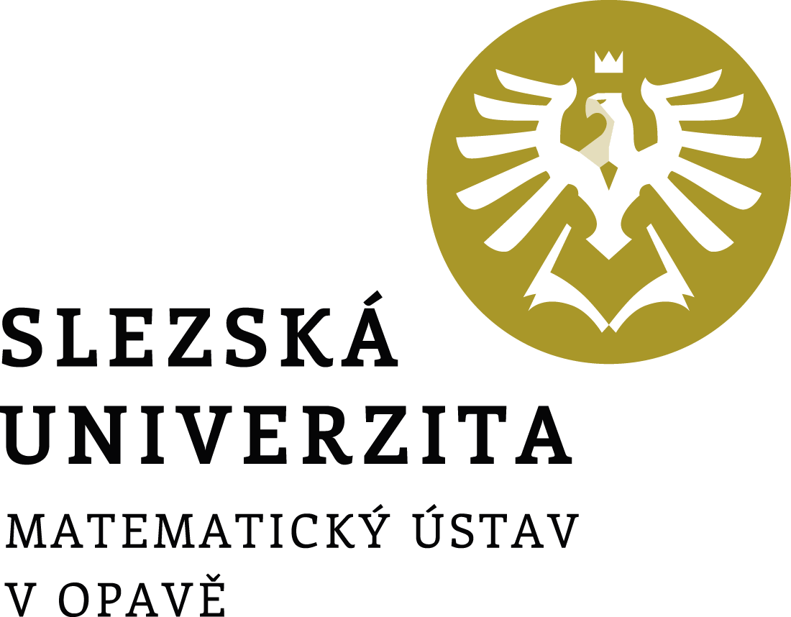

Director's Decision No. 2/2022

Academic Year Schedule

2022/2023

Director's Decision No. 2/2022

Academic Year Schedule 2022/2023

Article 1
Academic year schedule
In accordance with article 3, paragraph 6 of the Study and Examination Code for Students of Bachelor's and Master's Study Programmes of Silesian University in Opava, as amended, and following the Rector's Decision No. 4/2022 on Setting the Schedule for the Academic Year 2022/2023 at the Silesian University in Opava, I set further dates for the course of the academic year 2022/2023.

Beginning of the academic year | 1 Sept 2022
Enrolment for the academic year, enrolment of courses for the winter semester and study check | 1–16 Sept 2022
Teaching in the winter semester | 19 Sept–18 Dec 2022
Matriculation ceremony of the 1st year students of bachelor's studies | 10 Oct 2022
Graduation ceremony | 14 Oct 2022
Completing the documents for the assignment of bachelor's and master's theses in the IS SU | until 31 Oct 2022
Submission of printed assignments of bachelor's and master's theses to the Secretariat of the Mathematical Institute in Opava | until 7 Nov 2022
Holiday | 19 Dec 2022–1 Jan 2023
Exam period | 2 Jan–19 Feb 2023
Enrolment of courses for the summer semester | 1–10 Feb 2023
Teaching in the summer semester | 20 Feb–21 May 2023
Submission of bachelor's and master's theses for the 1st term of the state final examination (SFE) | until 21 May 2023
Exam period | 22 May–30 June 2023
Fulfilment of study obligations for admission to the 1st term of the SFE | until 4 June 2023
Registration for the 1st SFE term | until 4 June 2023
First term of the SFE (with the graduation ceremony in Oct 2023) | 19–30 June 2023
Holiday | 1 July–6 Aug 2023
Submission of bachelor's and master's theses for the 2nd term of the SFE | until 23 July 2023
Registration for the 2nd SFE term | until 23 July 2023
Exam period | 7 Aug–31 Aug 2023
Fulfilment of study obligations for admission to the 2nd term of the SFE | until 11 Aug 2023
Second term of the SFE (with the graduation ceremony in Oct 2023) | 21–31 Aug 2023
Fulfilment of study obligations for the academic year 2022/2023 | until 31 Aug 2023
End of the academic year | 31 Aug 2023

Article 2
State final examination application
Students register for the state final examination (SFE) via the IS SU: Study – Schedule of topics – State final examinations.

Article 3
Final provisions
This decision becomes valid and effective on the day it is published in the public part of the website.

In Opava on 7 June 2022 | Prof. RNDr. Miroslav Engliš, DrSc.
 | Director

University constituent: | Mathematical Institute in Opava
Designation: | Director’s decision
Number: | 2/2022
Directive title: | Academic Year Schedule 2022/2023
Approved by: | prof. RNDr. Miroslav Engliš, DrSc., Director
Derogation:
Valid from: | the day of publication
Effective from: | the day of publication
Date of publication: | 7 June 2022
Issued by: | Director
Processed by: | doc. RNDr. Zdeněk Kočan, Ph.D.
In cooperation with:
Number of pages: | 2
No. of appendices:
Method of publication: | the public part of the University website

