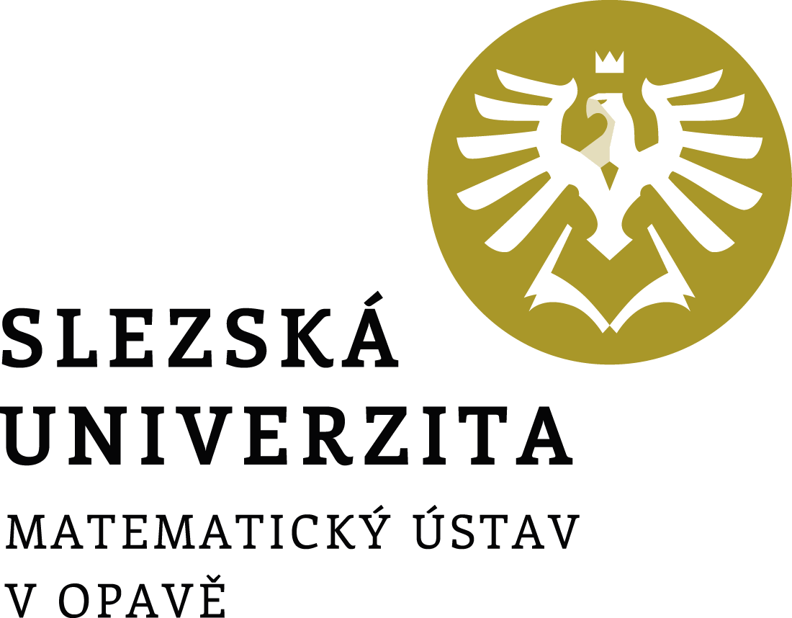

Director's Decision No. 2/2021

Academic Year Schedule

2021/2022

Director's Decision No. 2/2021

Academic Year Schedule 2021/2022

Article 1
Academic year schedule
In accordance with article 3, paragraph 6 of the Study and Examination Code for Students of Bachelor's and Master's Study Programmes of Silesian University in Opava, as amended, and following the Rector's Decision No. 4/2021 on Setting the Schedule for the Academic Year 2021/2022 at the Silesian University in Opava, I set further dates for the course of the academic year 2021/2022.

Beginning of the academic year | 1 Sept 2021
Enrolment for the academic year, enrolment of courses for the winter semester and study check for students of higher years | 7–17 Sept 2021
Enrolment for the academic year and enrolment of courses for the winter semester for the applicants from the 1st round of admissions | 8 Sept 2021
Enrolment for the academic year and enrolment of courses for the winter semester for the applicants from the 2nd round of admissions (the exact date shall be specified in the admission decision) | 15–16 Sept 2021
Teaching in the winter semester | 20 Sept–19 Dec 2021
Graduation ceremony | 8 Oct 2021
Matriculation ceremony of the 1st year students of bachelor's studies | 11 Oct 2021
Completing the documents for the assignment of bachelor's and master's theses in the IS SU | until 31 Oct 2021
Submission of printed assignments of bachelor's and master's theses to the Secretariat of the Mathematical Institute in Opava | until 8 Nov 2021
Holiday | 20 Dec 2021–2 Jan 2022
Exam period | 3 Jan–20 Feb 2022
Enrolment of courses for the summer semester | 14–18 Feb 2022
Teaching in the summer semester | 21 Feb–22 May 2022
Submission of bachelor's and master's theses for the 1st term of the state final examination (SFE) | until 22 May 2022
Exam period | 23 May–30 June 2022
Fulfilment of study obligations for admission to the 1st term of the SFE | until 5 June 2022
Registration for the 1st SFE term | until 5 June 2022
First term of the SFE (with the graduation ceremony in Oct 2022) | 20–30 June 2022
Holiday | 1 July–7 Aug 2022
Submission of bachelor's and master's theses for the 2nd term of the SFE | until 24 July 2022
Registration for the 2nd SFE term | until 24 July 2022
Exam period | 8 Aug–31 Aug 2022
Fulfilment of study obligations for admission to the 2nd term of the SFE | until 12 Aug 2022
Second term of the SFE (with the graduation ceremony in Oct 2022) | 22–31 Aug 2022
Fulfilment of study obligations for the academic year 2021/2022 | until 31 Aug 2022
End of the academic year | 31 Aug 2022

Article 2
State final examination application
Students register for the state final examination (SFE) via the IS SU: Study – Schedule of topics – State final examinations.

Article 3
Final provisions
This decision becomes valid and effective on the day it is published in the public part of the website.

In Opava on 3 June 2021 | Prof. RNDr. Miroslav Engliš, DrSc.
 | Director

University constituent: | Mathematical Institute in Opava
Designation: | Director’s decision
Number: | 2/2021
Directive title: | Academic Year Schedule 2021/2022
Approved by: | prof. RNDr. Miroslav Engliš, DrSc., Director
Derogation:
Valid from: | the day of publication
Effective from: | the day of publication
Date of publication: | 3 June 2021
Issued by: | Director
Processed by: | doc. RNDr. Zdeněk Kočan, Ph.D.
In cooperation with:
Number of pages: | 2
No. of appendices:
Method of publication: | the public part of the University website

