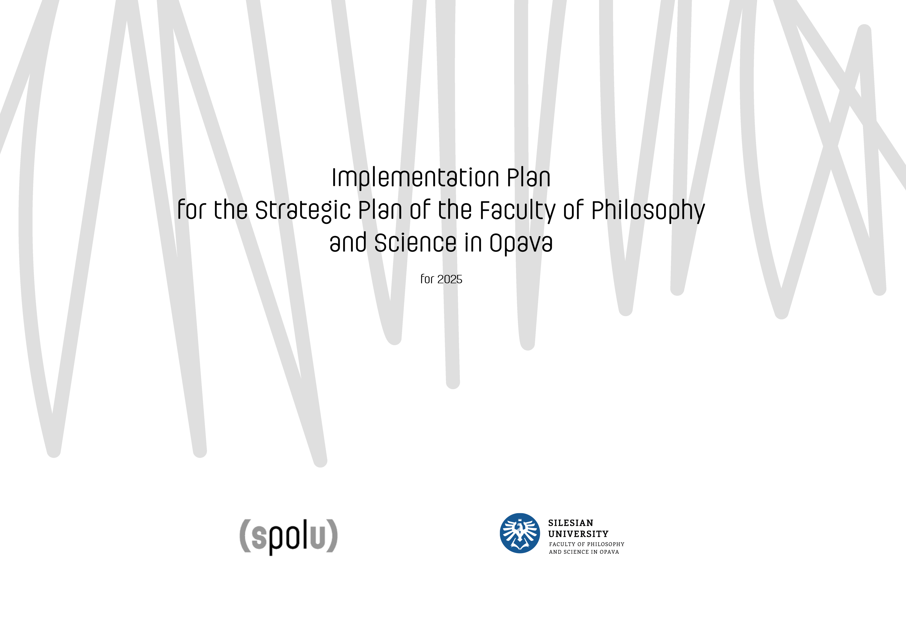

CONTENTS
INTRODUCTION 3
PRIORITY STRATEGIC AREAS 4
PRIORITY AREAS AND SPECIFIC OBJECTIVES 5
STUDY AND EDUCATION 7
SCIENCE, RESEARCH, AND OTHER CREATIVE ACTIVITIES 16
SOCIAL ROLE 21
INTERNATIONALIZATION 26
HUMAN RESOURCES DEVELOPMENT 31
PR & MARKETING AND IMAGE 35
STRATEGIC MANAGEMENT 39

INTRODUCTION
The Implementation Plan for the Strategic Plan of the Faculty of Philosophy and Science for 2025 is fully aligned with the Strategic Plan of the Faculty of Philosophy and Science 2021+. Its purpose is to support and advance the faculty’s strategic management. The primary aim of the plan is to specify the long-term priorities and objectives outlined in the strategic plan, building upon the specific measures and priorities defined within its framework. It sets out targeted activities that the faculty will focus on during the upcoming year.

This plan is closely connected to other strategic documents and certifications of the Silesian University in Opava, including:
- The Implementation Plan for the Strategic Plan of the Silesian University in Opava for 2025
- The Strategic Plan of the Silesian University in Opava for 2021+
- Planned activities of the Faculty of Philosophy and Science for 2025 related to the Ministry of Education’s Program for Supporting Strategic Management in Higher Education
- The HR Award Certificate – Excellence in Human Resources in Research
The following pages detail specific activities defined in the Strategic Plan of the Faculty of Philosophy and Science for 2021+ that the faculty plans to implement in 2025. These activities are derived from the specific objectives and measures outlined in the strategic plan. In 2025, all priority areas of this strategic intent will be further developed.
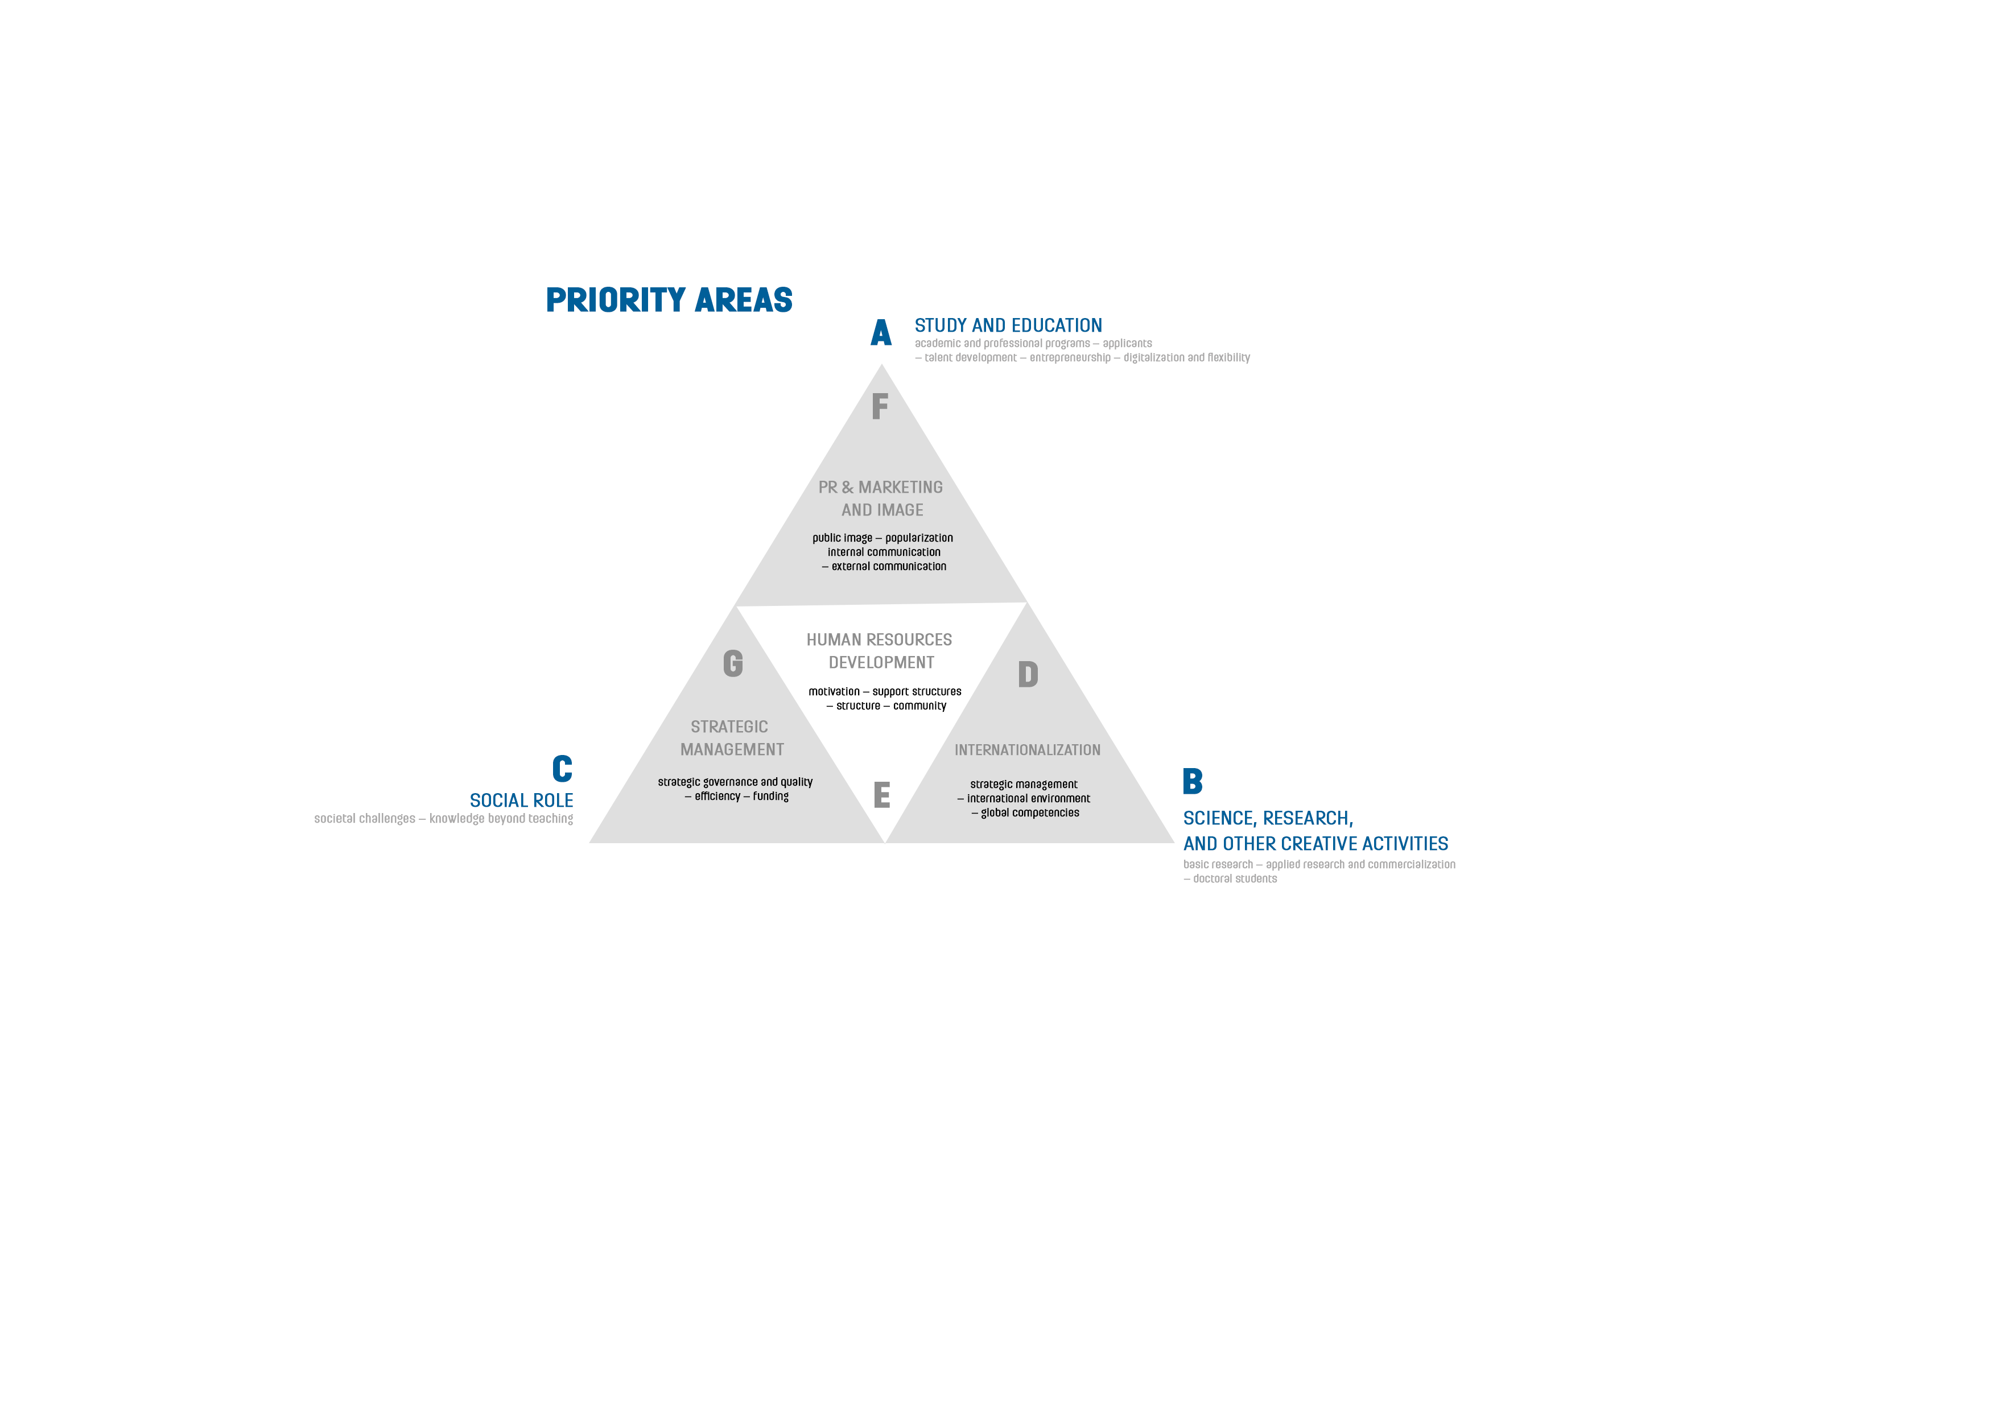

PRIORITY AREAS AND SPECIFIC OBJECTIVES

PRIORITY AREA A: STUDY AND EDUCATION
  - Developing professionally oriented study programs aligned with labour market needs, in collaboration with employers.
  - Developing unique academic study programs.
  - Stabilizing the number of students and attracting high-quality applicants.
  - Enhancing the quality and innovativeness of teaching.
  - Systematically supporting and nurturing talent.
  - Fostering student entrepreneurship and soft skills.
  - Promoting digitalization and incorporating distance-learning elements into education.
  - Developing an individualized approach and expanding support services for students.

PRIORITY AREA B: SCIENCE, RESEARCH, AND OTHER CREATIVE ACTIVITIES
  - Supporting basic research and other creative activities while considering the specific needs of individual units.
  - Promoting applied research and experimental development and increasing the production of commercializable outcomes in scientific, research, and creative activities.
  - Fostering collaboration and openness in creative activities.
  - Achieving excellence in doctoral students’ creative activities and improving the quality of postgraduate education.

PRIORITY AREA C: SOCIAL ROLE
  - Reflecting societal and current challenges, actively engaging in strategic regional development, and contributing to the life of university cities.
  - Fostering social responsibility.
  - Expanding the range of lifelong learning courses.
  - Supporting community life during and after studies.

PRIORITY AREA D: INTERNATIONALIZATION
  - Strengthening strategic management in the area of internationalization.
  - Creating an international learning environment.
  - Enhancing promotion and support services for international students and staff.
  - Expanding international mobility and global competencies of students and staff.

PRIORITY AREA E: HUMAN RESOURCES DEVELOPMENT
  - Strengthening motivation for personal and career development of employees.
  - Developing a proactive recruitment policy for academic and scientific staff and for filling senior positions.
  - Ensuring adequate support infrastructure for staff across all units.

PRIORITY AREA F: PR & MARKETING AND IMAGE
  - Streamlining and unifying communication across the university.
  - Promoting high-quality and effective marketing and public engagement.
  - Popularizing the outcomes of scientific and other creative activities.

PRIORITY AREA G: STRATEGIC MANAGEMENT
  - Strengthening the system of strategic management and enhancing the quality of teaching, research, and other creative activities.
  - Improving the efficiency and digitalization of internal processes.
  - Ensuring long-term internal financial stability.

Priority area A

STUDY AND EDUCATION
Specific objectives
  - Developing professionally oriented study programs aligned with market needs,
in collaboration with employers.
  - Developing unique academic study programs.
  - Stabilizing the number of students and attracting high-quality applicants.
  - Enhancing the quality and innovativeness of teaching.
  - Systematically supporting and nurturing talent.
  - Fostering student entrepreneurship and soft skills.
  - Promoting digitalization and incorporating distance-learning elements into education.
  - Developing an individualized approach and expanding support services for students.
  - DEVELOPING PROFESSIONALLY ORIENTED STUDY PROGRAMS ALIGNED WITH LABOUR MARKET NEEDS, IN COOPERATION WITH EMPLOYERS
Measure: Innovating contractual cooperation with the applied sector to ensure a smooth transition of graduates into practice (participation in teaching, arranging internships, and other joint activities).

Involve industry professionals in educational activities, organize events to promote innovate teaching in collaboration with practice, and support students in engaging in professional activities.
Specific outputs
    - Industry professionals actively participating in educational activities.
    - Events organized to promote innovative teaching practices in cooperation with industry.
    - Students receiving support for their professional development.

Person responsible
Vice Dean for Study Affairs and Organization.

Deadline
31 December 2025
Measure: Applying proven on-site and online communication tools with employers and other professionals to ensure continuous alignment of graduate profiles with labour market demands.

Create capacities and opportunities to deepen collaboration with employers (round tables, workshops, professional events).
Specific outputs
    - Round tables, workshops, professional events, etc.

Person responsible
Vice Dean for Study Affairs and Organization.
Deadline
31 December 2025

  - DEVELOPING UNIQUE ACADEMIC STUDY PROGRAMS
Measure: Supporting creative activities in the natural sciences, humanities, and social sciences linked to the teaching process.

Support the creative activities of academic staff and talented students engaged in creative and artistic projects and student competitions.
Specific outputs
    - Students involved in the faculty’s scientific, research, and other creative activities.
    - Supported students with published outputs.
    - Presented results of students participating in creative activities.

Person responsible
Vice Dean for Science and International Relations.
Vice Dean for Study Affairs and Organization.

Deadline
31 December 2025

  - STABILIZING THE NUMBER OF STUDENTS AND ATTRACTING HIGH-QUALITY APPLICANTS
Measure: Ongoing evaluation of the effectiveness of measures aimed at reducing study failure rates.

Continuously evaluate the effectiveness of measures taken to reduce study failure rates.
Specific outputs
    - Annual written evaluation of study failure rates in relation to the expansions and innovation of study supports in the IS SU.

Person responsible
Vice Dean for Study Affairs and Organization.
Deadline
31 December 2025
Measure: Creating a network of prominent individuals, including academic staff, external experts, public authorities, and successful alumni involved in the teaching process, organization of popularization lectures, public competitions, etc.

Strengthen measures aimed at reducing study failure by increasing the involvement of distinguished academics and external experts in teaching.

Specific outputs
    - An updated network of prominent academics outside the faculty.
    - Popularization lectures, public competitions, etc.

Person responsible
Vice Dean for Study Affairs and Organization.
Deadline
31 December 2025
Measure: Strengthening the position of the faculty among prospective students through modern technologies and promotional channels.

Target and engage the prospective students using modern channels.
Specific outputs
    - Increased awareness and interest in the study programs.

Person responsible
Vice Dean for Study Affairs and Organization.
Head of the Centre for Marketing and Communication.
Deadline
31 December 2025

  - ENHANCING THE QUALITY AND INNOVATIVENESS OF TEACHING
Measure: Supporting platforms for teaching staff to share experiences and information on innovations and examples of best practices (seminars, conferences, round tables, etc.).

Promote activities and tools for teaching staff to share experiences and information on innovations through examples of best practices.
Specific outputs
    - Seminars, conferences, round tables, etc.

Person responsible
Vice Dean for Study Affairs and Organization.
Vice Dean for Strategy and Development.
Deadline
31 December 2025
Measure: Developing collaboration with public, professional, and non-profit sectors in the implementation of internships and creation of assignments for theses.
Engage domestic and international experts in teaching, innovation, and supervision of theses.

Specific outputs
    - External experts involved in the teaching process.

Person responsible
Vice Dean for Study Affairs and Organization.
Deadline
31 December 2025

  - SYSTEMATICALLY SUPPORTING AND NURTURING TALENT
Measure: Involving selected talented students in creative and artistic projects.

Engage selected talented students in research, development, artistic, and other creative activities, including domestic and international grants and internal projects.
Specific outputs
    - Published and presented outputs of students in the field of basic and applied scientific research and artistic activities.

Person responsible
Vice Dean for Study Affairs and Organization.
Vice Dean for Science and International Relations.
Deadline
31 December 2025
Measure: Supporting student participation in student competitions in the Czech Republic and abroad.

Encourage student participation in student competitions in the Czech Republic and abroad.
Specific outputs
    - Students participating in student and other competitions.

Person responsible
Vice Dean for Study Affairs and Organization.
Deadline
31 December 2025

  - FOSTERING STUDENT ENTREPRENEURSHIP AND SOFT SKILLS
Measure: Involving students in workshops, projects, presentations, and other activities in collaboration with professional practice.

Support various forms of knowledge transfer between the academic and professional sectors, with active student participation (e.g. workshops, projects, and specific collaborations with professional practice).
Specific outputs
    - Students involved in the organization of workshops, projects, and other activities.
    - Workshops, projects, presentations, and other events featuring student participation.

Person responsible
Vice Dean for Study Affairs and Organization.
Vice Dean for Strategy and Development.
Deadline
31 December 2025

  - PROMOTING DIGITALIZATION AND INCORPORATING DISTANCE-LEARNING ELEMENTS INTO EDUCATION
Measure: Developing and utilizing digital platforms for study resources and online communication within the IS SU environment.

Develop a database of study and other learning resources for students in the IS SU environment.
Specific outputs
    - New or innovated distance learning tools available in the IS SU.

Person responsible
Vice Dean for Study Affairs and Organization.
Vice Dean for Strategy and Development.
Deadline
31 December 2025

  - DEVELOPING AN INDIVIDUALIZED APPROACH AND EXPANDING SUPPORT SERVICES FOR STUDENTS
Measure: Supporting individualized approach to students with specific needs (e.g. study materials, modification of course completion formats, etc.).

Support individualized approach to students with specific needs.
Specific outputs
    - Counselling and individual consultations on academic and social
matters at the faculty level.

Person responsible
Vice Dean for Study Affairs and Organization.
Deadline
31 December 2025
Measure: Modernizing accommodation facilities and dining options.

Support innovation in accommodation.
Specific outputs
    - Modernized accommodation inventory.

Person responsible
Secretary.
Deadline
31 December 2025
Measure: Modernizing accommodation facilities and dining options.

Support innovation in accommodation and dining services.
Specific outputs
    - Modernized accommodation inventory and mobile payment options for dining.

Person responsible
Secretary.
Deadline
31 December 2025
Measure: Supporting barrier-free access to learning spaces, including necessary equipment to meet the needs of various spaces.

Promote barrier-free accessibility in premises of the faculty.
Specific outputs
    - Expansion of the faculty buildings with barrier-free access – preparation for the construction of a passenger lift at Hradecká 17 as part of specific project calls.

Person responsible
Vice Dean for Study Affairs and Organization.
Secretary.
Deadline
31 December 2025

Priority area B

SCIENCE, RESEARCH, AND OTHER CREATIVE ACTIVITIES
Specific objectives
  - Supporting basic research and other creative activities while considering the specific needs of individual units.
  - Promoting applied research and experimental development and increasing the number of applicable and commercializable outcomes in scientific, research, and other creative activities.
  - Fostering collaboration and openness in creative activities.
  - Achieving excellence in doctoral students’ creative activities and improving the quality
of postgraduate education.

  - SUPPORTING BASIC RESEARCH AND OTHER CREATIVE ACTIVITIES WHILE CONSIDERING THE SPECIFIC NEEDS OF INDIVIDUAL UNITS
Measure: Supporting presentation and popularization of the results of basic research, artistic, and other creative activities.

Support the organization of international professional conferences at the faculty to present the results of basic research and artistic activities.
Specific outputs
    - International scientific conferences and professional workshops showcasing the results of research teams.

Person responsible

Vice Dean for Science and International Relations.
Head of institutes and research centres.
Deadline
31 December 2025
Measure: Supporting open access to research and development results in line with the national strategy.

Support the publication of scientific research results in periodicals indexed in recognized databases (WoS, SCOPUS), in domestic and international peer-reviewed journals, and on other platforms, with an emphasis on open access.
Specific outputs
    - Published results of artistic and other creative activities in a manner that is appropriate for the field, utilizing open access formats.

Person responsible
Vice Dean for Science and International Relations.
Deadline
31 December 2025
Measure: Supporting international cooperation in scientific, research, and
artistic activities and public presentation of their results

Cooperate with domestic and international institutions and support participation in international projects.
Specific outputs
    - Submitted international projects or research tasks undertaken by research teams with international representation.

Person responsible

Vice Dean for Science and International Relations.
Head of institutes and research centres.
Deadline
31 December 2025

  - PROMOTING APPLIED RESEARCH AND EXPERIMENTAL DEVELOPMENT AND INCREASING THE NUMBER OF APPLICABLE AND COMMERCIALIZABLE OUTCOMES IN SCIENTIFIC, RESEARCH, AND OTHER CREATIVE ACTIVITIES
Measure: Supporting presentation and popularization of the results of applied and contract research and other creative activities.

Organize festivals, exhibitions, international meetings, etc. to present the results of artistic creativity at home and abroad.
Specific outputs
    - Art festivals.
    - Professional and art exhibitions.

Person responsible

Vice Dean for Science and International Relations.
Heads of institutes.
Deadline
31 December 2025
Measure: Organizing joint events with representatives from the professional and application spheres to exchange information and foster collaboration.

Organize round tables, workshops, and other social events to exchange information and
develop collaboration.
Specific outputs
    - Round tables.
    - Workshops.
Person responsible

Vice Dean for Science and International Relations.
Heads of institutes.
Deadline
31 December 2025

  - FOSTERING COLLABORATION AND OPENNESS IN CREATIVE ACTIVITIES
Measure: Organizing interdisciplinary conferences.

Support collaboration between faculty departments and teams across disciplines in the areas of scientific research, artistic, and other creative activities. Present the results of science, research, artistic, and other creative activities to the professional community at home and abroad.
Specific outputs
    - Concrete results of cooperation with domestic and international institutions across the disciplinary spectrum (conferences, workshops, round tables, etc.).

Person responsible
Vice Dean for Science and International Relations.
Heads of institutes and research centres.
Deadline
31 December 2025

  - ACHIEVING EXCELLENCE DOCTORAL STUDENTS’ CREATIVE ACTIVITIES AND IMPROVING THE QUALITY OF POSTRAGUDATE EDUCATION
Measure: Systematically improving awareness and motivation of doctoral students.

Organize informational workshops for doctoral students to enhance awareness, increase motivation to study, and create conditions for sharing knowledge and experience.
Specific outputs
    - Informational workshops for doctoral students.

Person responsible
Vice Dean for Science and International Relations.
Deadline
31 December 2025

Measure: Involving international experts in teaching and scientific training for doctoral students.

Support the creation of international evaluation committees for doctoral theses defences in selected fields. Involve international experts in teaching and scientific training for doctoral students. Create an international study environment for international students with an emphasis on doctoral programs.
Specific outputs
    - Doctoral thesis defences with at least one international opponent or committee member.
    - Lectures / seminars / workshops led by international experts.

Person responsible
Vice Dean for Science and International Relations.
Deadline
31 December 2025

Measure: Ensuring competent supervision of research and artistic activities for doctoral students with adequate individual communication.

Support the involvement of doctoral students in projects, research, and creative teams at various departments.
Specific outputs
    - Expert supervision of projects, grants, and research teams involving doctoral students.

Person responsible
Vice Dean for Science and International Relations.
Deadline
31 December 2025

Priority area C

SOCIETAL ROLE
Specific objectives
  - Reflecting societal and current challenges, actively engaging in
strategic regional development, and contributing to the life of university cities.
  - Fostering social responsibility.
  - Expanding the range of lifelong learning courses.
  - Supporting community life during and after studies.

  - REFLECTING SOCIETAL AND CURRENT CHALLENGES, ACTIVELY ENGAGING IN STRATEGIC REGIONAL DEVELOPMENT, AND CONTRIBUTING TO THE LIFE OF UNIVERSITY CITIES
Measure: Organizing professional and cultural activities for the public.

Organize and co-organize social, cultural, professional, popularization and educational activities for students and the public in the university city and region.
Specific outputs
    - Participation in cultural, social, professional, popularization events
in the city and the region (Colours of Ostrava, Majáles, Slunovrat, SOČ).
- Creation and implementation of cultural content at the faculty and in the visitor centres for students and the public (Noc vědců, Týden Akademie věd, Robotický Xboj, Opavský páv, Na Cestě, activities at the visitor centres U Vavřince and Rybí pavilon).

Person responsible
Dean.
Vice Dean for Strategy and Development.
Secretary.
Head of Centre for Marketing and Communication.
Deadline
31 December 2025
Measure: Organizing professional and cultural activities for the public.

Organize and co-organize social, cultural, professional, popularization and educational activities for students and the public.

Specific outputs
- Cultural, social, educational and popularisation programme in the visitor centres and faculty for the public, professionals and students (3).
- Active participation in regional social, cultural and popularization and educational events (Noc vědců, Týden Akademie věd, Slunovrat, Opavský páv).

Person responsible

Dean.
Vice Dean for Strategy and Development.
Secretary.
Head of Centre for Marketing and Communication.
Deadline
31 December 2025

  - FOSTERING SOCIAL RESPONSIBILITY
Measures: Increasing waste separation, focus on energy savings and sustainability.

Promote sustainability and environmentally friendly practices.
Specific outputs
    - Separation of all types of waste in the faculty buildings using modernized
facility infrastructure.
    - Utilization of local composting (composters) for organic waste.
    - Use of FILTERMAC devices to reduce the use of PET bottles.

Person responsible
Vice Dean for Strategy and Development.
Secretary.
Deadline
31 December 2025

  - EXPANDING THE RANGE OF LIFELONG LEARNING COURSES
Measure: Increasing number of courses organized by the faculty.

Continue to participate in the development of new lifelong learning courses and
promote them on the SU website.
Specific outputs
    - Participation on the current lifelong learning courses, especially MOOCs
(Massive Open Online Courses).

Person responsible
Vice Dean for Strategy and Development.
Vice Dean for Study Affairs and Organization.
Deadline
31 December 2025

  - SUPPORTING COMMUNITY LIFE DURING AND AFTER STUDIES
Measure: Providing facilities for student organizations and activities, actively engaging students in faculty events.

Maintain regular communication with students to encourage their participation in
social events organized by the faculty.
Specific outputs
    - Students actively involved in faculty events.

Person responsible
Vice Dean for Strategy and Development.
Vice Dean for Study Affairs and Organization.
Deadline
31 December 2025

Priority area D
INTERNATIONALIZATION
Specific objectives
  - Strengthening strategic management in the area of internationalization.
  - Creating an international learning environment.
  - Enhancing promotion and support services for international students and staff.
  - Expanding international mobility and global competencies of students and staff.
- STRENGTHENING STRATEGIC MANAGEMENT IN THE AREA OF INTERNATIONALIZATION
Measures: Continuously evaluating the internationalization strategy in medium- and long-term
perspectives.

Continuously seek new possibilities for the existing internationalization strategy, with focus on the specific needs of institutes, and regularly evaluate the proposed internationalization strategy of the faculty.
Specific outputs
- Evaluation of the proposed concept of internationalization in the medium-term perspective.

Person responsible
Vice Dean for Science and International Relations.
Deadline
31 December 2025
Measure: Optimizing the network of collaborating international institutions.

Continuously explore opportunities for new collaborations and strengthen ties with existing international partners, focusing on the specific needs of institutes.
Specific outputs
- Optimized structure of international partnerships beneficial for development
and effective cooperation with international partners.

Person responsible
Vice Dean for Science and International Relations.
Deadline
31 December 2025

- CREATING AN INTERNATIONAL LEARNING ENVIRONMENT
Measure: Increasing the number of international experts involved in teaching,
science, research, and related educational and creative activities.

Nurture contacts with international universities, research and other organizations and individuals with the potential to participate in teaching. Create favourable conditions for short and long-term stays of international academics involved in teaching, science and research, and other creative activities with an impact on the educational process.
Specific outputs
    - Short- and long-term stays of international academics.
    - International experts involved in teaching and related educational
activities.

Person responsible
Vice Dean for Science and International Relations.
Head of institutes.
Deadline
31 December 2025

Measure: Utilizing external and internal financial resources to support bilateral mobility to enhance the international learning environment.

Support bilateral mobility stays. Seek external funding and evaluate grant and scholarship programs aimed at developing international mobility of students and academic staff.
Specific outputs
    - Supported mobilities of academic staff.
    - International mobilities funded through external financial sources.

Person responsible

Vice Dean for Science and International Relations.
Head of institutes.
Deadline
31 December 2025

- ENHANCING PROMOTION AND SUPPORT SERVICES FOR INTERNATIONAL STUDENTS AND STAFF
Measure: Preparing and regularly updating documents, information, and promotional materials for international students and guests in print and online formats.

Maintain a welcoming and friendly environment for international students and staff. Continuously enhance the awareness of international students about study opportunities and possible involvement in creative activities using traditional and modern platforms and information channels. Regularly update and expand promotional materials in English for international students and staff.
Specific outputs
    - Presentation and promotional materials in English.
    - Regularly updated information platforms in foreign languages (online and offline communication channels such as social media, leaflets, brochures).
    - Updated documents in foreign languages.

Person responsible

Vice Dean for Science and International Relations.
Head of the Centre for Marketing and Communication.
Secretary.
Deadline
31 December 2025
Measure: Supporting user-friendly web for international mobility participants.

Regularly update and innovate web pages for international mobility participants. Effectively use the website and social media for communication with international students. Develop internationally oriented marketing activities.

Specific outputs
    - Updated English content of the English website section “International Relations and Erasmus+”.
    - Creation of English content specifically for doctoral students.
    - Internationally targeted marketing activities for foreign audiences.

Person responsible
Vice Dean for Science and International Relations.
Head of the Centre for Marketing and Communication.
Deadline
31 December 2025
Measure: Integrating international students and staff into faculty life

Actively support the involvement of international students and staff in educational and social activities to aid their integration. Promote active leisure activities for international students and staff by offering cultural, recreational, and sports activities.
Specific outputs
    - Engagement of international students and staff in faculty activities.
    - Events for both domestic and international students (Erasmus Days, Welcome Days, etc.).

Person responsible
Vice Dean for Science and International Relations.
Head of the Centre for Marketing and Communication.
Deadline
31 December 2025

- EXPANDING INTERNATIONAL MOBILITY AND GLOBAL COMPETENCIES OF STUDENTS AND STAFF
Measure: Regularly update the university website with information about international mobility opportunities.

Regularly update the university website about international mobility opportunities. Update the website as new types of mobility emerge.
Specific outputs
    - Information platforms dedicated to international mobility for students and academic staff.
Person responsible
Vice Dean for Science and International Relations.
Deadline
31 December 2025
Measure: Supporting the integration of completed international mobility programs into the students’ individual study plans.

Motivate students and academic staff to participate in short- and long-term international mobility program to enhance the quality of international cooperation and foster international partnerships. Promote new forms of student and staff mobility (e.g. virtual, hybrid, short-term mobility, and blended intensive programs).
Specific outputs
    - Participation of students and academic staff in international mobility programs.
Person responsible
Vice Dean for Science and International Relations.
Deadline
31 December 2025
Measure: Organizing educational activities and training for the faculty staff on internationalization and supporting participation in external training courses.

Organize informational workshops, training sessions, and other educational activities for faculty staff in the area of internationalization.
Specific outputs
    - Workshops on opportunities for international study and internships.
    - Erasmus+ workshops.
    - Language courses for academic and non-academic staff.

Person responsible
Vice Dean for Science and International Relations.
Deadline
31 December 2025
Measure: Organizing language courses for students, academic, and non-academic staff.

Organize English language courses for faculty staff.
Specific outputs
    - Language courses for academic and non-academic staff.
Person responsible
Vice Dean for Science and International Relations.
Deadline
31 December 2025

Priority area E

HUMAN RESOURCES DEVELOPMENT
Specific objectives
  - Strengthening motivation for personal and career development of employees.
  - Developing a proactive recruitment policy for academic and scientific staff and for filling senior positions.
  - Ensuring adequate support infrastructure for staff across all units.

  - STRENGTHENING MOTIVATION FOR PERSONAL AND CAREER DEVELOPMENT OF EMPLOYEES
Measure: Developing and regularly updating tools for evaluating academic staff and other employees.

Develop a tool within the budged to motivate employees across all categories though salary incentives.
Specific outputs
- Creation of a fund for educational and creative activities and its targeted use.

Person responsible
Dean.
Heads of institutes/workplaces.
Secretary.
Deadline
31 December 2025
Measure: Implementing a career development system linked to the employee evaluation system, based on the updated Career Code.

Support the alignment of research, development, and teaching activities (taking into account the role of supervisor/mentor vs. fulfilling other job responsibilities).
Specific outputs
- Monitoring the competency development of employees.

Person responsible
Dean.
Heads of institutes/workplaces.
Secretary.
Deadline
31 December 2025

  - DEVELOPING A PROACTIVE RECRUITMENT POLICY FOR ACADEMIC AND SCIENTIFIC STAFF AND FOR FILLING SENIOR POSITIONS
Measure: Establishing recruitment and selection procedures for academic and other positions, while emphasizing transparency, adherence to the OTM-R principles, compliance with anti-discrimination policies, and promoting gender equality.

Set clear guidelines for recruitment and selection procedures at the faculty level with a focus on transparency, the OTM-R principles, anti-discrimination policies, and gender equality.
Specific outputs
    - Selection procedures to fill academic and other positions that adhere to the OTM-R principles.

Person responsible
Dean.
Heads of institutes/workplaces.
Secretary.
Deadline
31 December 2025
Measure: Training senior staff on the principles of the OTM-R principles.

Conduct training sessions for senior employees on the OTM-R principles.
Specific outputs
    - Training of senior employees on the OTM-R principles.
Person responsible
Dean.
Heads of institutes/workplaces.
Secretary.
Deadline
31 December 2025
Measure: Implementing the OTM-R principles.

Support onboarding processes.
Specific outputs
    - Revision of documents related to recruitment and hiring policies.

Person responsible
Dean.
Heads of institutes/workplaces.
Secretary.
Deadline
31 December 2025

  - ENSURING ADEQUATE SUPPORT INFRASTRUCURE FOR STAFF ACROSS ALL UNITS
Measure: Responding flexibly to opportunities for innovation in the working environment and facilities through grants from the Ministry of Education, Youth and Sports, and other external providers.

Prepare conditions for relocating faculty departments to premises managed by the faculty.
Specific outputs
    - Initiation of activities aimed at relocating selected faculty workplaces.

Person responsible
Dean.
Vice Dean for Strategy and Development.
Secretary.
Deadline
31 December 2025

Priority area F

PR & MARKETING AND IMAGE
Specific objectives
  - Streamlining and unifying communication across the university.
  - Promoting high-quality and effective marketing and public engagement.
  - Popularizing the outcomes of scientific and other creative activities.

  - STREAMLINING AND UNIFYING COMMUNICATION ACROSS THE UNIVERSITY
Measure: Creating and continuously updating the student handbook.

Update and edit information.
Specific outputs
    - Implementation of new information and updates in the student handbook.

Person responsible
Head of the Centre for Marketing and Communication.
Vice Dean for Strategy and Development.
Deadline
31 December 2025

  - PROMOTING HIGH-QUALITY AND EFFECTIVE MARKETING AND PUBLIC ENGAGEMENT
Measure: Ongoing cooperation with key institutions at the regional and supra-regional levels,
focusing on relevant target groups.

Regular cooperation and development of a positive image with institutions targeting
relevant groups (cultural institutions, educational institutions, local governments, etc.).
Specific outputs
    - Open days and departmental/consultation days at the faculty.
    - Active communication and creation of popularizing and informational content for the general public (5 articles in RO, faculty social media, faculty visitor centres).

Person responsible
Head of the Centre for Marketing and Communication.
Deadline
31 December 2025

  - POPULARIZING THE OUTCOMES OF SCIENTIFIC AND OTHER CREATIVE ACTIVITIES
Measure: Mentoring key staff in the area of popularization and promotion.

Development and education in the area of promotion and popularization.
Specific outputs
    - Participation in workshops and lectures with key personnel.

Person responsible
Head of the Centre for Marketing and Communication.
Deadline
31 December 2025
Measure: Realizing events at the visitor centres, organized autonomously or in cooperation with external partners.

Create and implement audiovisual and popularizing content.
Specific outputs
    - Popularizing, artistic and creative content for the general public (faculty
podcast Pavillon and 12 popularizing audiovisual materials).

Person responsible
Head of the Centre for Marketing and Communication.
Deadline
31 December 2025

Priority area G

STRATEGIC MANAGEMENT
Specific objectives
  - Strengthening the systems of the strategic management and enhancing the quality of teaching,
research, and other creative activities.
  - Improving the efficiency and digitalization of internal processes.
  - Ensuring long-term internal financial stability.

  - STRENGTHENING THE SYSTEM OF STRATEGIC MANAGEMENT AND ENHANCING
THE QUALITY OF TEACHING, RESEARCH, AND OTHER CREATIVE ACTIVITIES.
Measure: Courses focusing on management and strategic management.

Support faculty staff education through courses in management and strategic management.
Specific outputs
    - Completion of courses in management and strategic management by faculty staff.
    - Implementation of activities aimed at improving the quality of teaching and creative activities (workshops, courses, etc.).
Person responsible
Dean.
Vice Dean for Strategy and Development.
Secretary.
Heads of institutes/workplaces.
Deadline
31 December 2025
Measure: Supporting competencies in management and leadership.

Support for the education of senior faculty members.
Specific outputs
    - Teambuilding for senior faculty members, including an educational workshop on management and leadership (1).
Person responsible
Dean.
Vice Dean for Strategy and Development.
Secretary.
Heads of institutes/workplaces.

Deadline
31 December 2025

  - IMPROVING THE EFFICIENCY AND DIGITALIZATION OF INTERNAL PROCESSES
Measure: Rules for digitizing processes and their implementation at the middle management level.

Collaborate in the implementation of university-wide digitization of selected administrative processes.
Specific outputs
    - Introduction of digitalization into selected administrative processes at the middle management level.

Person responsible
Vice Dean for Strategy and Development.
Secretary.
Deadline
31 December 2025

  - ENSURING LONG-TERM INTERNAL FINANCIAL STABILITY
Measure: Analysing the current state of affairs and subsequent recommendations for the specific direction of the faculty in the area of funding education, science, research, and other creative activities.

Conduct annual analysis of the funding of students, financial resources for education, science, research, and creative activities in relation to faculty’s organizational structure and the stability of its funding.
Specific outputs
    - Annual analysis of funding according to relevant sources.

Person responsible
Dean.
Secretary.
Deadline
31 December 2025

Submitted by: prof. PhDr. Irena Korbelářová, Dr., Dean
Reviewed by the Scientific Council of the SU FPS on: 17 October 2024
Approved by the Academic Senate of the SU FPS on: 4 November 2024

Silesian University in Opava

Faculty of Philosophy and Science in Opava

Masarykova třída 343/37, 746 01 Opava

www.fpf.slu.cz

