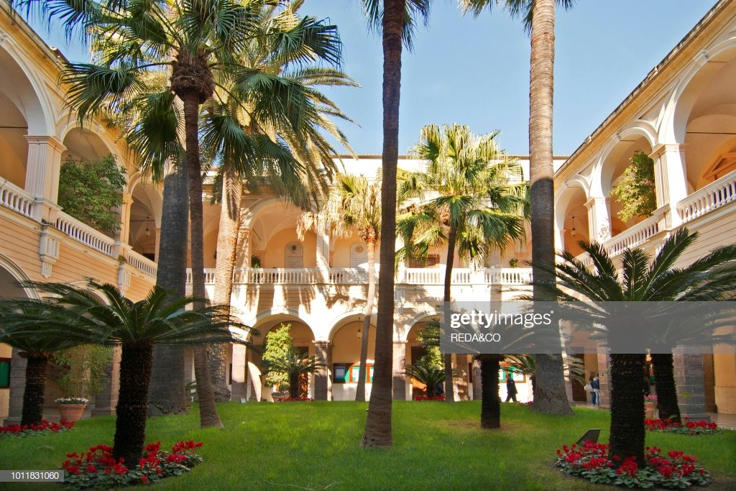

The University of Sassari is the oldest in Sardinia, founded by the [Jesuits](https://en.wikipedia.org/wiki/Society_of_Jesus) in 1562, and it gained the first place in 2009 in the ranking for the best “medium-sized” Italian university.

**ENJOY SARDINIA!!!**

* **Study in the library or enjoy sand beaches, sunshine and sea while preparing for your classes.**
* **Visit plenty of archaeological sights all over the city as well as the island or visit local museums.**
* **Join your friends in festivals and parades, listen to genuine Italian music and enjoy genuine Italian cuisine with local fish, olives and wine.**
* **Meet new people to study and enjoy your free time with.**
* **Take breath-taking photos, live like an Italian and enjoy your study in a holiday resort.**

