

Kristianstad University (HKR) is a small but at the same time large university in southern Sweden. The university is gathered in one campus situated just 10 minutes from the town centre of Kristianstad. Our keywords are openness, curiosity and respect. Kristianstad University offers 50 programmes and 300 courses, all of which are distinguished by science, research and great pedagogical quality. At the university campus you can find everything you need within a short walking distance. There is a library, a restaurant, a café, the student union, health centre and student dormitories all in one place. In the middle of the campus you will find a spacious library with study rooms, computer rooms and open spaces where you can read or relax.

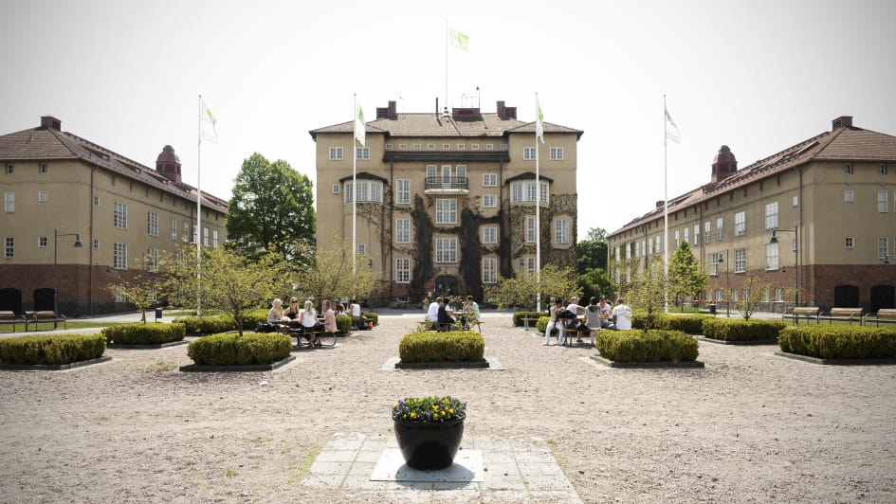

**ENJOY SWEDEN!!!**

* **Improve your English in the English-speaking environment every day.**
* **Get materials and write your final thesis in a library with study rooms and computer rooms.**
* **Meet new friends from all over the world.**
* **Spend your free time walking around coastline suitable for hiking, sailing or try rock climbing.**
* **Relax in a shopping centre, cafés or in the city park.**
* **Experience various cultural events, visit a theatre, concert hall, art gallery or city museums. Malmo is only one hour away with public transport.**