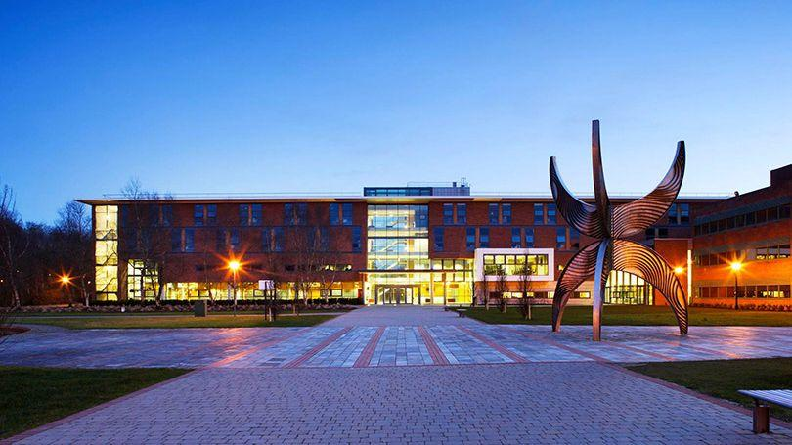

The University of Limerick (UL), is located on the west coast of Ireland along the picturesque River Shannon and enjoys an unspoiled natural environment blended with state-of-the-art teaching and research facilities. UL offers more than 70 undergraduate programmes across Arts, Humanities and Social Sciences; Education and Health Sciences, Science and Engineering and the Kemmy Business School. Cafes, restaurants, student and faculty accommodation options and a range of on-campus facilities provide an outstanding student experience and a stimulating working environment.

**ENJOY IRELAND!!!**

* **Improve your English in the English-speaking environment every day.**
* **Get materials and write your final thesis in one of the greatest libraries with help of local teachers.**
* **Meet new friends from all over the world.**
* **Spend your free time in one of many cafes or restaurants available on campus, or join a sport group, from archery to rowing.**
* **Relax during sightseeing tours organized by UL – visit breath-taking Cliffs of Moher, Star Wars locations on Dingle Peninsula, take photos at the Atlantic Ocean or in the Ring of Kerry, learn about Irish history in castles and folk parks.**
* **Experience various cultural events, genuine Irish music, food and drinks.**